What is a search engine?

A search engine is the medium through which you can find relevant (or irrelevant) information on the World Wide Web. Search engines come in many forms based on who constructs them and for what audience.

Search engines that are directory based

These search engines are “catalogued” by people and divided into headings and sub headings. These type of search engines represent a more traditional “library style” organisation.

http://www.yahoo.com

Search engines that are keyword searched

These search engines use computer software to search web pages for key words and classify them accordingly into predefined areas. Many search engine companies charge for the honour of being searchable.This can make them suspect on occassion

http://www.hotbot.com
http://www.directhit.com
http://www.goto.com
http://www.altavista.com/
http://infoseek.go.com
http://www.northernlight.com

Specialist search engines

These search engines search web pages that are specific to a subject area or discipline.

http://www.lessonplanz.com/
http://www.film.com/search/
http://www.cnn.com/SEARCH/

Search engines for kids

1) | FunBrain.com
2) | Kidpub.org
3) | Kids Domain
4) | Scholastic.com
5) | Yahooligans!

Natural language search engines

These search engines allow you to type in questions the way you would ask them.

http://www.askjeeves.com

Metasearch engines
These search engines combine the use of other search engines.

http://www.redesearch.com
http://www.ixquick.com/
www.metacrawler.com

New search engines

Search engines are undergoing extensive changes – new ones appear, old ones die. The deal is to be flexible in your approach and to plan your searches.

I can recommend a new type of search engine which is easy to use and offers great results. Try

http://www.google.com to get an idea of the new breed of search engine.

How do I find a search engine?

Well you can link right off this page OR

You can type the address in the address bar of your browser
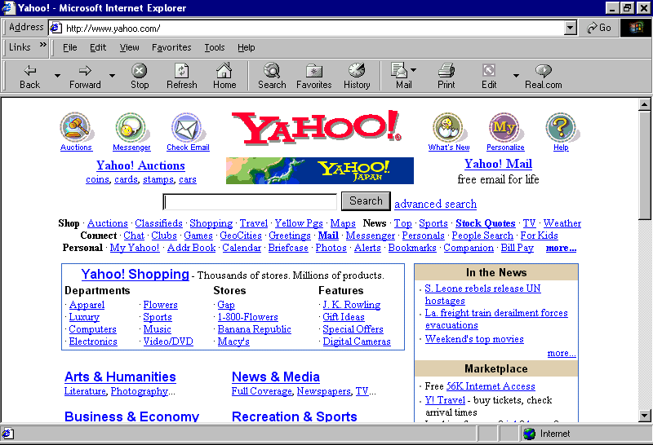

Or you can link in form the schools webpage using the ENGLISH PAGE and then SEARCH ENGINES links.

There is even a search engine that searches for search engines

try –

http://www.invisibleweb.com/
for that specific area of interest.

