- Open the program

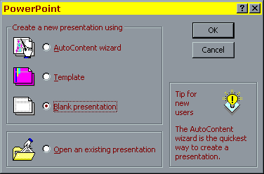
- At this window choose “Blank Presentation” then OK

3.At this screen choose what layout you want (The one selected is a blank page) click OK

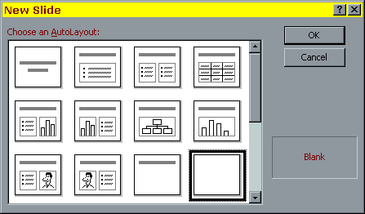
A blank page will appear on the screen this is a SLIDE.

Adding things to slides

Background

Do a right mouse click in the centre of the page and choose background from the menu
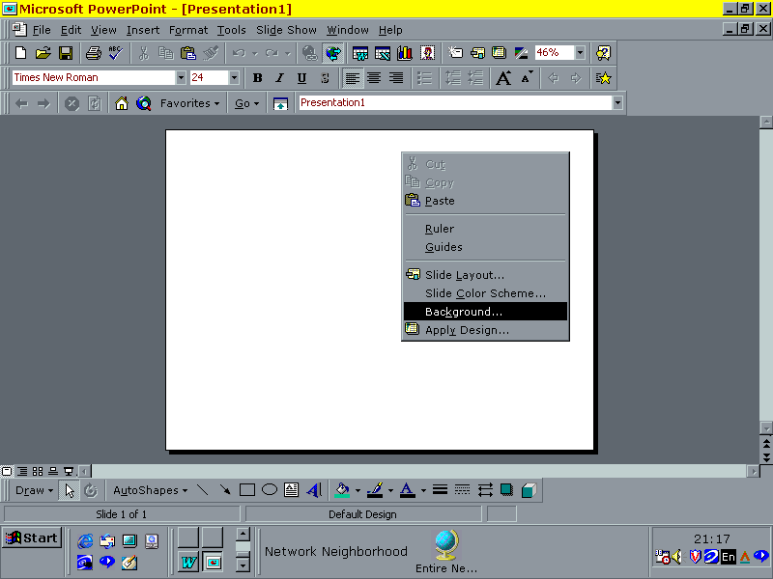
Colour
To make a colour background choose more colours from the pull down menu. A pallette will appear and you can choose a colour.

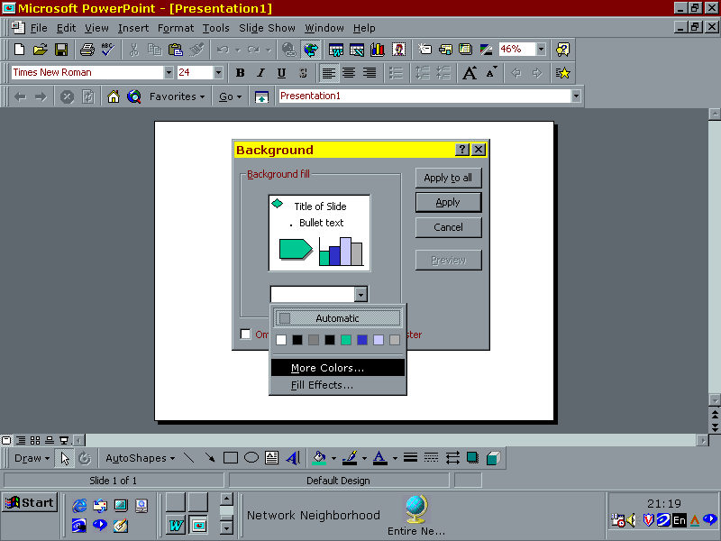
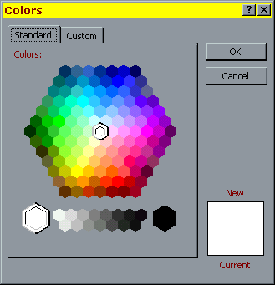

Click OK when a colour is chosen and then APPLY

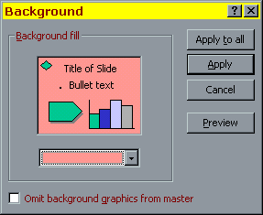

To Choose a THEME for your slide. Right click on the slide choose –background

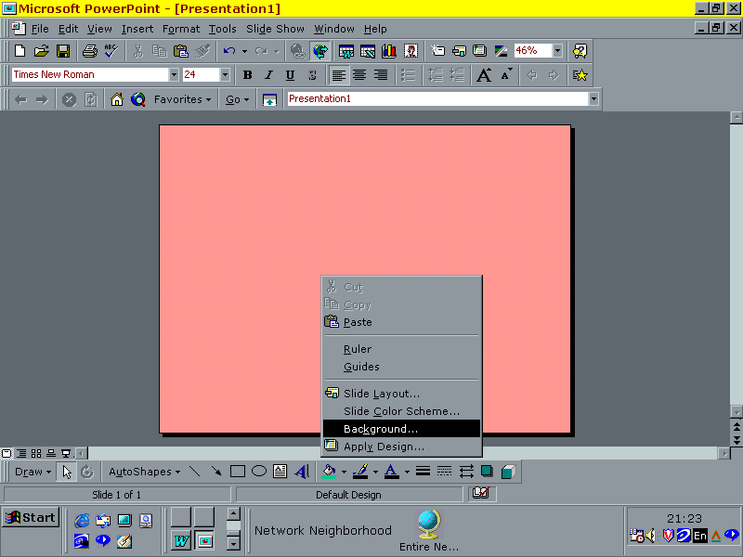

Choose FILL EFFECTS

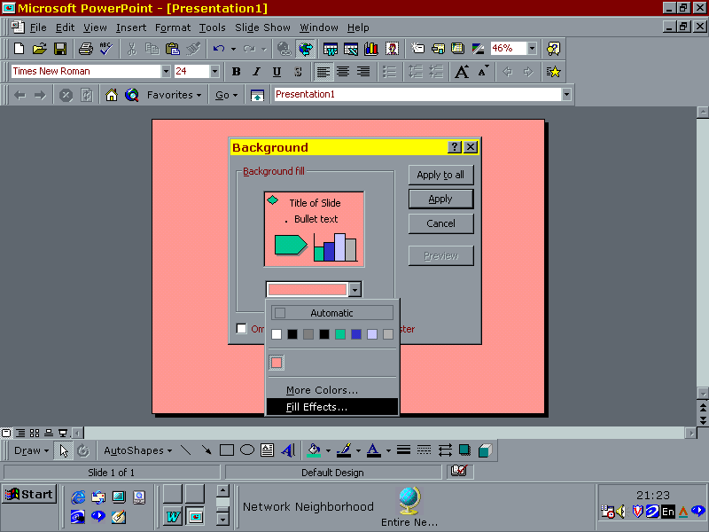

Choose any one of the colours textures or patterns using the tabs

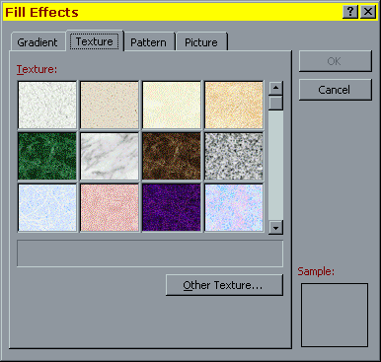

Now go to SLIDE SORTER
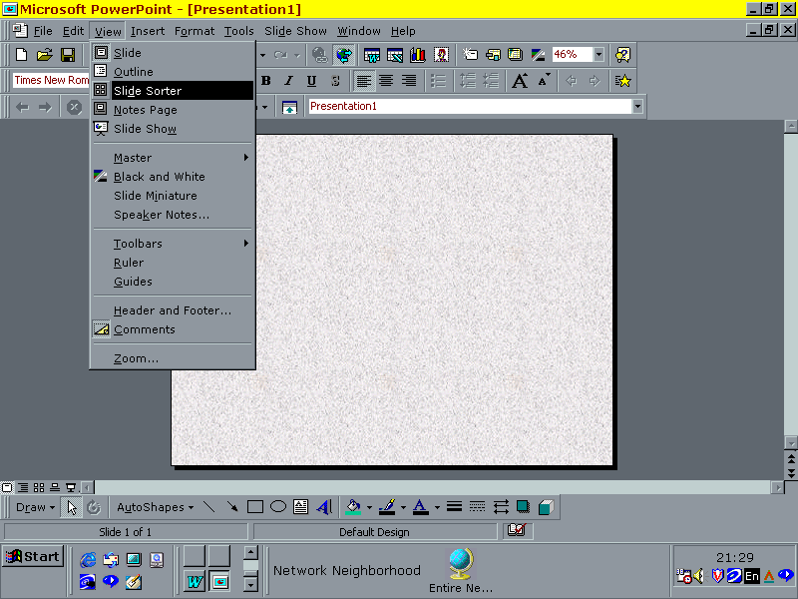
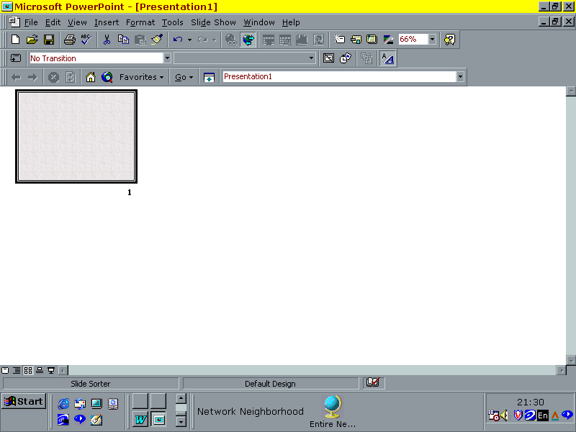

This gives you a view of your one slide presentation

To add more slides (say a total of five) go to INSERT/NEW SLIDE

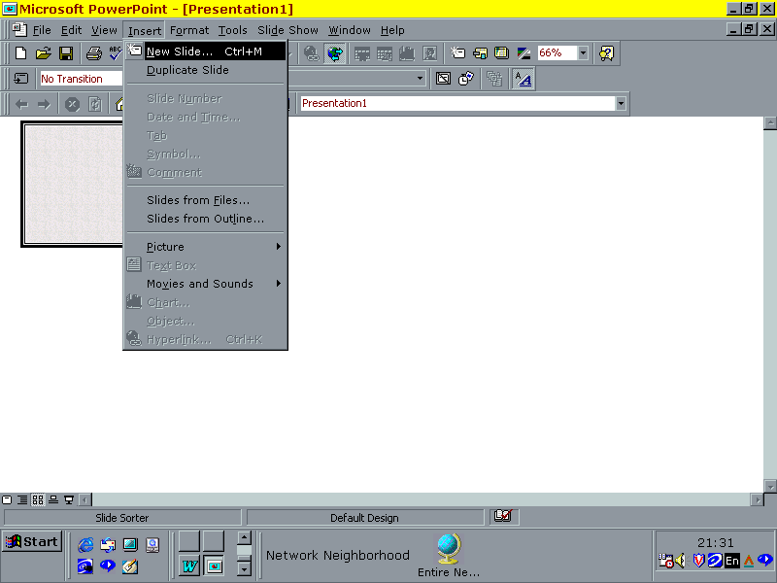
Choose the new slide format
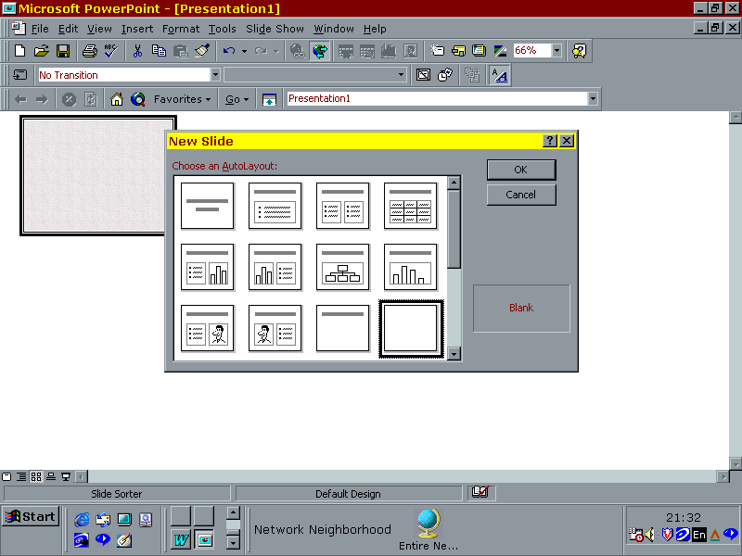
Click OK and repeat until there are 5 slides
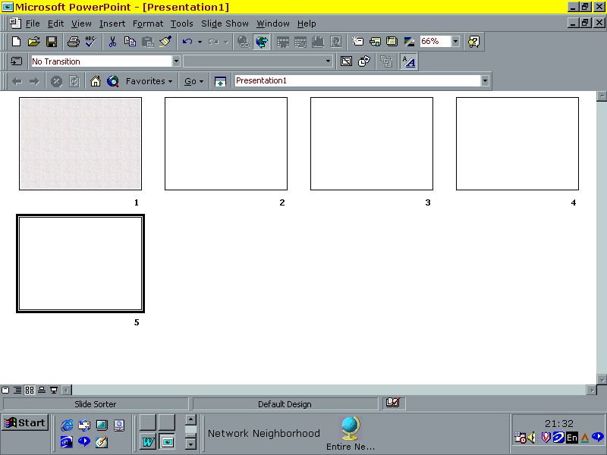
To get a background on each double click on your first slide

Do the right hand click choose background and follow these processes except choose APPLY TO ALL instead of APPLY.

You can change the background at any time with a Right hand click in the slide

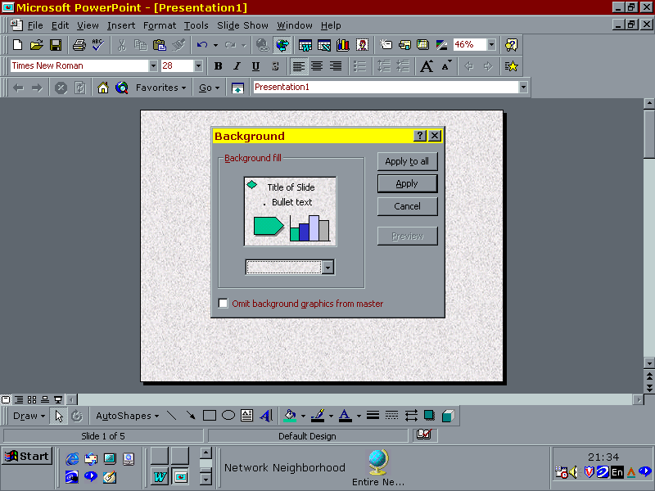
This is your final result on the slide sorter

