Creating a simple web page using Frontpage.

The most important part of web page creation is PRE PLANNING. You should ask yourself –is this is the right format for wht I am trying to get across? What do I want on my web page? How can I make my web page interesting? And other such questions. You should map out your web on paper before you start the process.

The basic elements of a web page (or homepage)

Text – You should experiment with the font and style and the general layout of text,. Too much text is tiresome on the user. Your web page should not be a replacement for a word procesing document in general. Text colour is an important consideration.

Hyperlinks –your page should have links to other pages and sources whether in your web or to existing internet sources.

Graphics – make your homepage look better but there are overcrowding issues that take from the appeal.

Background –A simple background that relates to the topic of your page is most appropriate.

The process

Open Microsoft Frontpage

Open a new page (File /New / Page)

You can choose a preformatted page in this program but we will start with a Normal Page
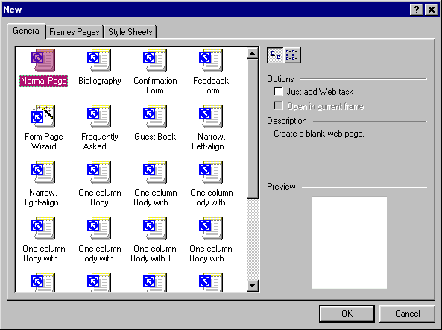

Creating a fancy heading/subheadings

Enter your text heading or subheading highlight or select and then use FORMAT FONT to create headings in different fonts and colours. It is best to do this at the completion of your page as the font will stay the same for all text you input after making the settings.
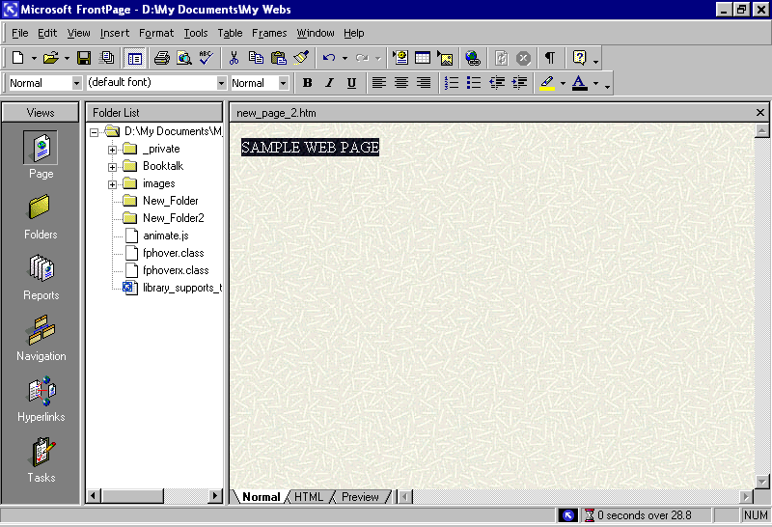

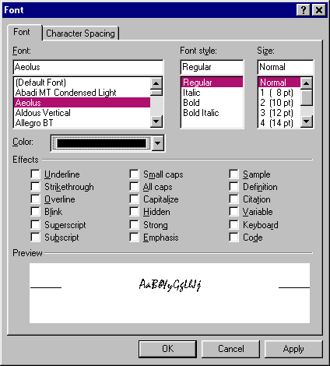

Graphics

Insert Graphics like clipart/scanned images/digital images using the INSERT/PICTURE and choose clipart or a file that you have saved of your own.

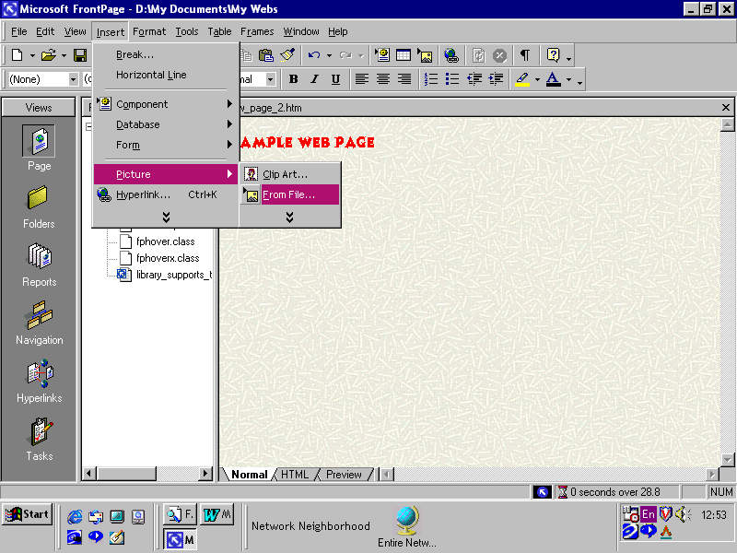

When importing clipart follow the procedure below
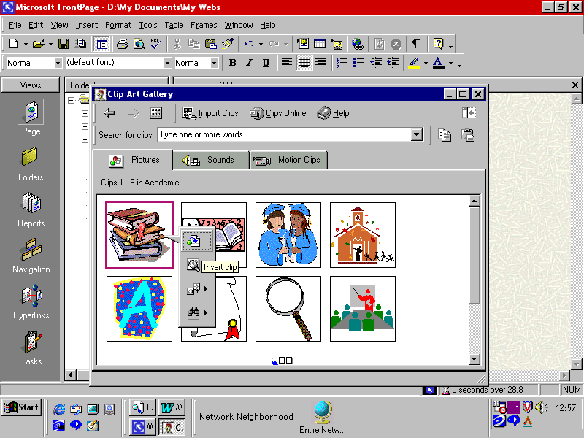

You can format and change the size of images using the black dots around the imported picture
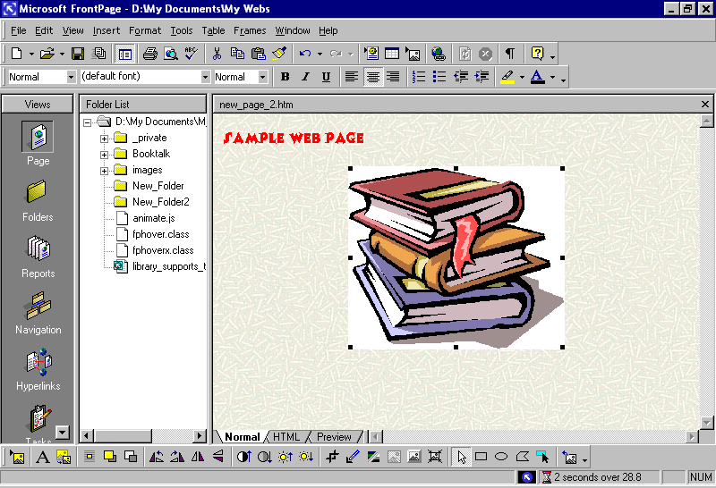

The same procedures apply to any image imported.

There are a few ways to make a background for your web page.

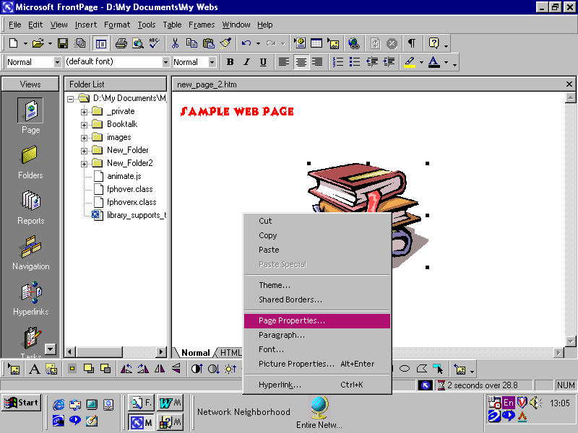
For a plain colour background – Make a right hand mouse click in the middle of your page, choose PAGE PROPERTIES.

This will open a window
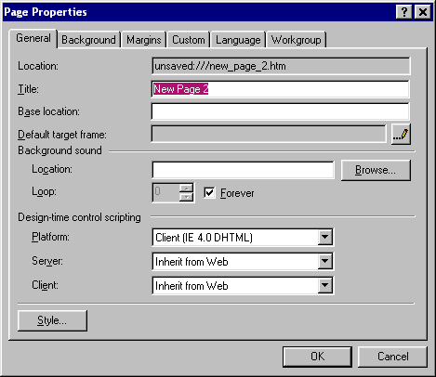

Choose the background tab. On the background colour arrow. Choose from a selection of colours for your background.

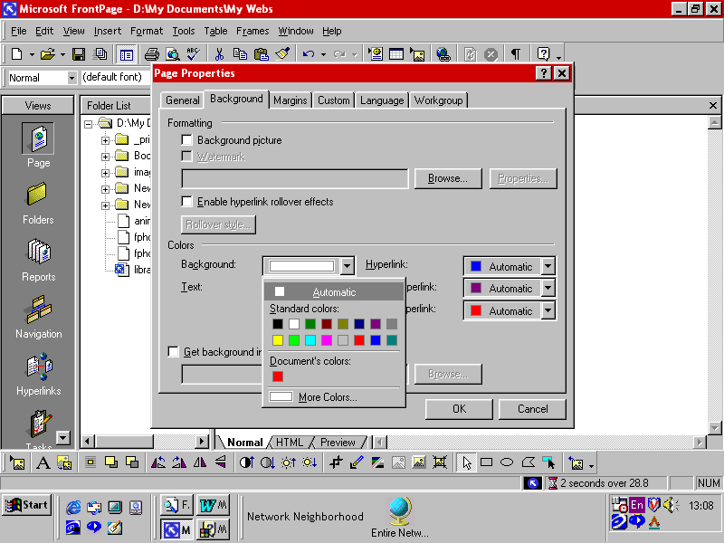

Another way to create a background is use a preformatted theme. I’ll show you the basics but it will be up to you to explore the huge number of possibilities using themes.

A right mouse click in the centre of the page and choose THEME

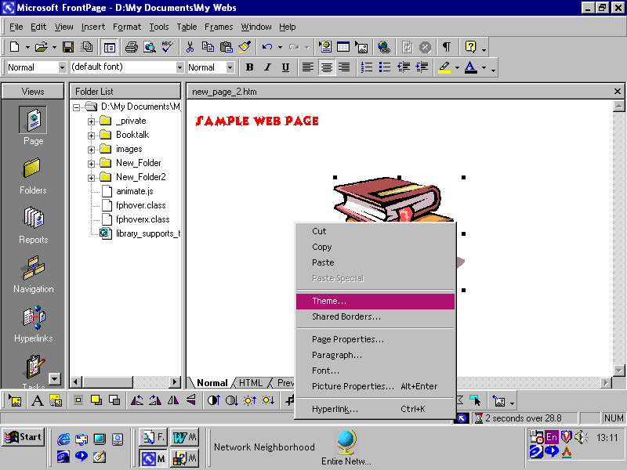
Choose a theme from the list and OK

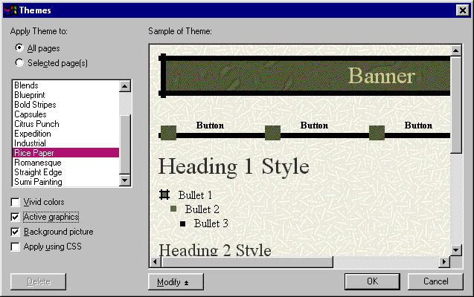
You can do any number of changes using the MODIFY button at the bottom of this window.

Now that was the easy part.

You now have to create a number of HYPERLINKS to other pages which you have created/will create.

Refer to your written plan and create your pages using the procedure above.

Save all of your pages into ONE FOLDER with easily recogniseable names for each one. In fact when you save, save everything to this folder (the program will do this automatically on most occassions).

CREATE THE FOLDER (usually in your MUTSUKI TEACHER FOLDER)

Open your mutsuki folder (the one that is in your name) using NETWORK NEIGHBOURHOOD or MY COMPUTER or whatever the usual way you do these things.

When you have opened your folder do a right mouse click in the centre of the window (or any blank space in the window) and choose NEW and FOLDER. This will create a new folder to save to. Click on the folder and then click on the text “new folder” to change the name of the folder (You just type it in). Name the folder using the subject of your web pages.

Back into frontpage now.

Choose FILE /SAVE AS

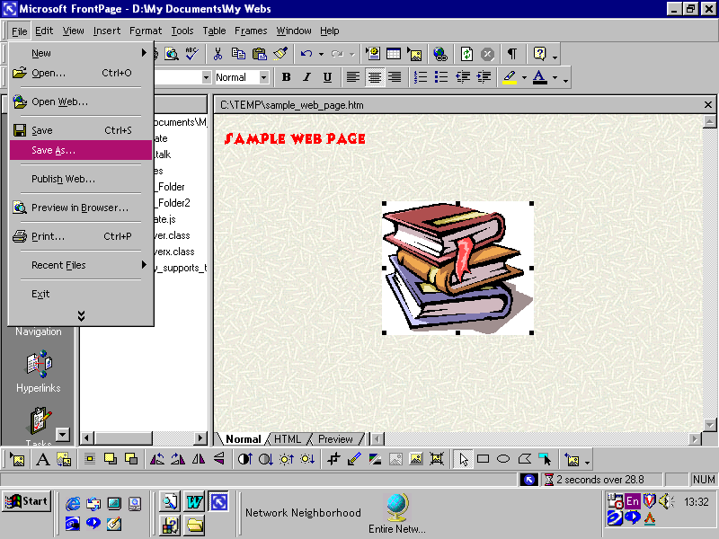
Save to the folder you have created. You will see a window that says “Save embedded files” – these are all the bits you have created –graphics, backgrounds etc etc. Just click OK.

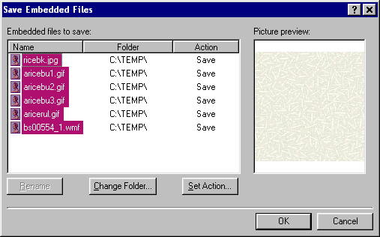

WARNING!

Save the files you create regularly –some of the functions you are about to include on each page will not work unless a page is saved recently.

Right –

Lets say you have created 3 pages in the manner above and saved them all to your created folder. (I have called mine sample web page , sample web page 2 and sample web page 3 and I have saved them to a TEMP file/folder (You will of course have saved them to your created Mutsuki folder)

The next step is to link them together using HYPERLINKS.

You can create different types of links using a number of methods –

Text links

Type in your text (“link to sample web page 2”) Highlight the text and choose INSERT/HYPERLINK or you can use the hyperlink symbol on the toolbar.
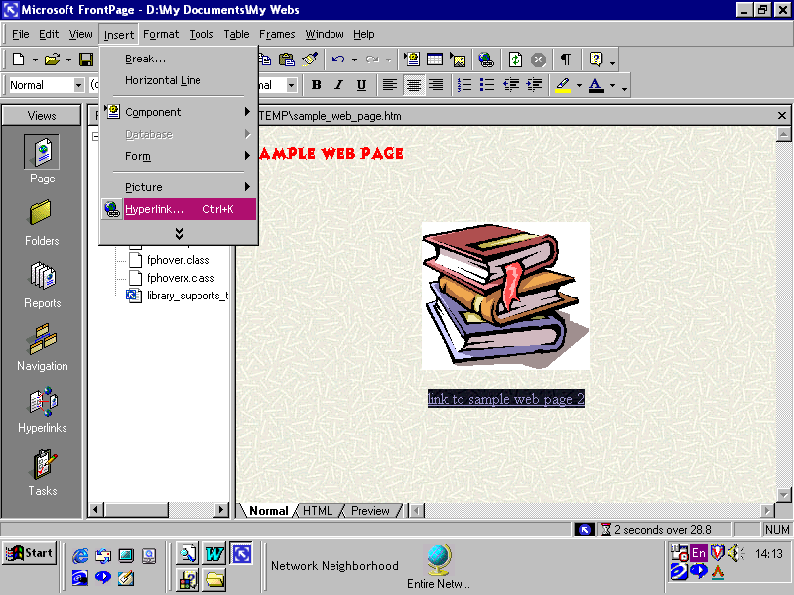

A window will appear which asks you where you wish to link to (in this case I will link to sample web page 2)

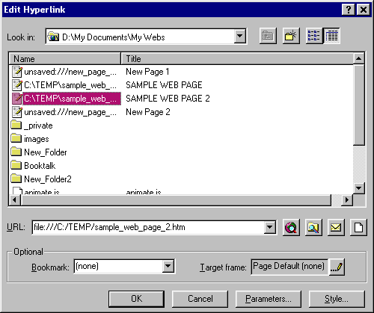
Choose the page you wish to link to and click OK.

Save your pages after doing this.

To TEST A LINK.

Open your main or home page.

At the bottom of the page change from the NORMAL tab to the PREVIEW tab. Place your cursor over the text link and click it. (a hand appears when you hover over the link.)
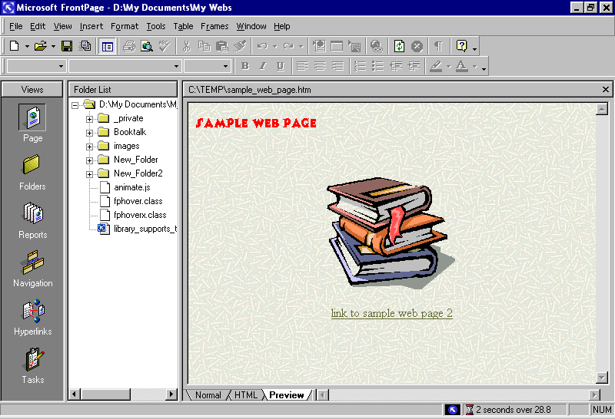

To return to work on your page click back onto the NORMAL tab.

Using graphics as links.

A graphic can be used as a hyperlink vehicle. Lets use the books graphic to link to our sample web page 2.
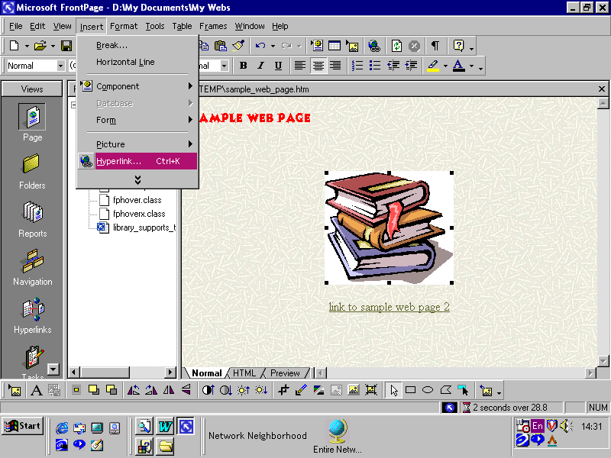
Select the graphic (black dots will appear around it. Now choose INSERT and then HYPERLINK (or the toolbar icon OR a right mouse click in the middle of the graphic.)

Test the link in the same manner as a text link.

Using HOVER BUTTONS

A neat way to create hyperlinks involves using hover buttons.

I am going to open Sample Web page 2 to run you through this process. I am going to create a hover button that links back to Sample Web page 1 (otherwise known as my home or main page).

To create a hover button choose INSERT/COMPONENT/HOVER BUTTON
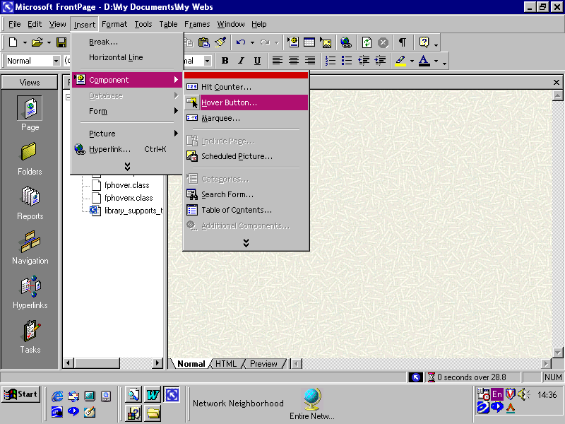

This window will appear

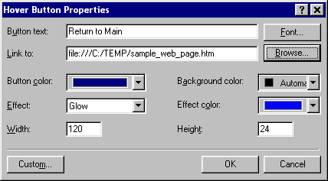
Button text – Type in the text you want to appear on the button – I am using Return to Main.

Link to –Browse to find your home or main page ( In my case sample web page)

You can change the colour, background colour of the button and the effect colour ( this button gives a neat two tone effect when you place your cursor over it)

This is how it looks on your screen.

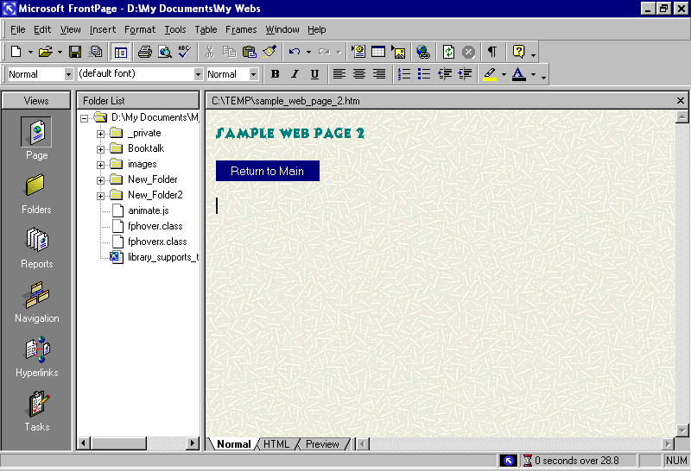

Test the link in the same manner as a text link.

You can change the properties of your hover button at any time by double clicking on it.

You should put a “home” or “main” link on every page (apart from your “home” page) for easy navigation by users.

You can preview your web site in a browser (like Internet Explorer) by selecting FILE/PREVIEW IN BROWSER to give you an idea of what it will look like on the web.

Links to other things

You can make links to email addresses and other web sites on the internet

Email links

I will use sample web page to show this.

Create a hyperlink using text, graphics or a hover button. (look back you know how to do it!)

Select the email icon and type in an email address (I’ve used mine here)
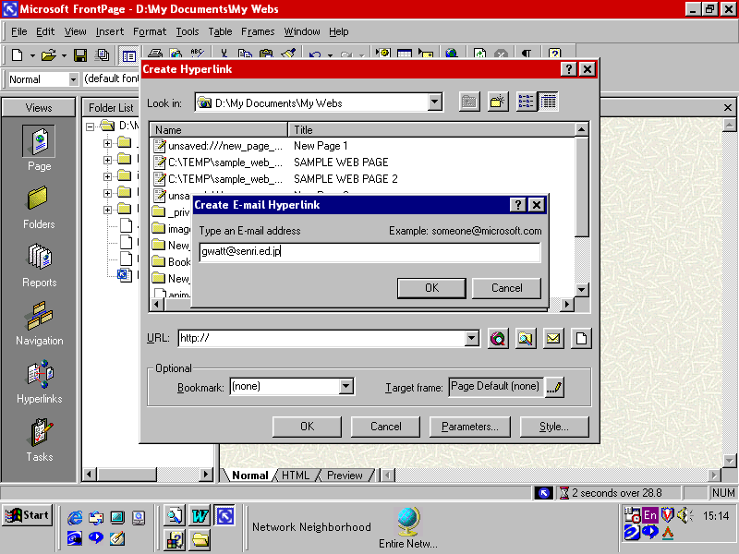
Click OK and then OK again

To link to a URL (web address). Create the hyperlink in the usual manner (text, graphics or hover button)
And type in or browse for a URL. I have used yahoo as the link.

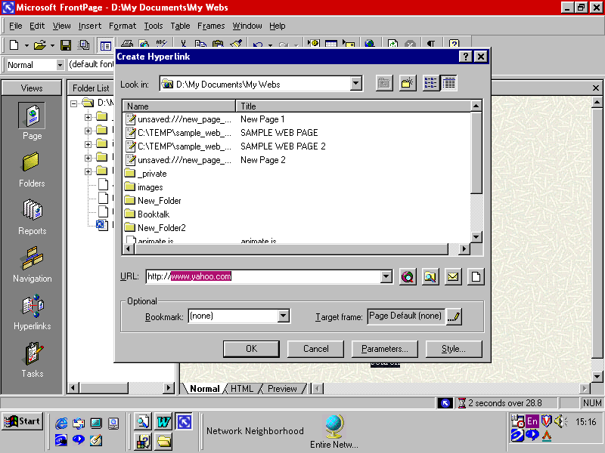

This is a very basic web site that you can create . To actually publish it is a matter of checking procedures with your Internet Service Provider (at home) or the network technical support staff (at school). There are many other functions available to you – please enjoy discovering the many interesting things you can do in creating a web site.

There are many sites on the internet to gather web graphics and animations and also to help you create a great web site. Try some of these links

http://www.actden.com/fp2000/java/index.htm
http://dwwd.com/graphics/fp2ktutorials.htm
http://www.fss.is/fptutor/default.htm
http://www.library.unt.edu/info/media/Tutorial/part_one.htm

Good Luck

Greg Watt
May 2000

