MYP Year 5
Graded Homework
2008-09-03

You should do all of your work on a separate piece of paper. Show all of your work, neatly written in an organized manner. This assignment is due in class on September 10.

1. The Internet has become a major tool for any institution that uses computers. In fact some businesses do nothing but work on material to exchange over the World Wide Web and methods to make the exchanges faster. Usually programmers and designers put information into Hypertext Markup Language (HTML) thus making it available to others. One major consideration is the concept of “load time.” This is the time that it takes to transfer one document from one computer to another. There are many factors that influence this but one of the most obvious is the length of the document.

Suppose you are starting a company that wanted to provide the complete works of literature to English classes around the world. The programmers who work for you have gathered some sample novels and calculated the load time, where x is the total number of words and y is the load time in seconds.

a. What is the slope of the equation?
- Using your own words, what does the slope mean?
- What is the y-intercept of the equation?
- Using your own words, what does the y-intercept represent?
- Write the equation in standard form.
- Graph the equation
- Gulliver’s Travels by Jonathon Swift has 106,014 words. According to this model how long would it take to load?
- Flatland by Edwin Abbot has 14,784 words. How long would it take?
- Titus Andronicus by William Shakespeare has 22,962 words. How long would it take?
- Research has shown that users will not wait more than one minute for downloads. Which of the books in #7 – 9 (if any), would download in time?
- What would you suggest as a remedy for books that take too long to download?
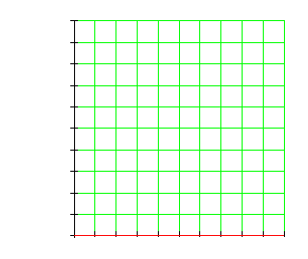
2. The Ostrich Internet Scheme (OIS for short) raises and trains sled ostriches and dancing emus. The breeders at OIS can supply at most 20 emus and at most 15 ostriches in a year. Each emu eats 2 kg/day and each ostrich eats 6 kg/day. Unfortunately, OIS can only store 100 kgs of food each day. An emu requires 1000 hours of training each year while an ostrich requires 250 hours of training. OIS cannot provide more than 16,000 hours of training each year.
a. Label the axes, emus on the x-axis and ostriches on the y.
b. Write an inequality for the amount of food eaten. Graph and shade this on the graph.
c. Write an inequality for the amount of training time. Graph and shade this on the graph, using a different color.
d. If both of the inequalities have to be true, what is the region that makes it true? Shade this a different color.
e. If we want to maximize the number of birds on our farm, how many of each kind of bird should we have?

