ITGS Exam Prep 10 Name: _________________________________
2.4.2. Robotics
The chances of having an obedient robot do unwelcome or dangerous jobs have increased tremendously, with orders for industrial robots rising to a record 18 per cent in the first half of this year. In homes about 4 million autonomous vacuum cleaners and lawn-mowers are already in operation. Right now Japan uses about 320 robots of all sorts per 10,000 employees, while Germany uses 148 industrial robots per 10,000 employees. In the car industry alone, there is one robot per 10 workers in Japan, Italy and Germany.
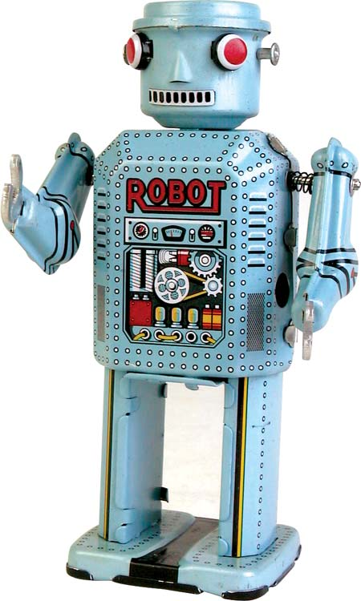

- Define android and cyborg [2 marks]
___________________________________________________________________________________________________________________________________________________________________________________________________________________________________________________________________________________________________________________________________________________________________________________________________________
- Humans have used tools and machines to assist them since the dawn of time. Distinguish between a traditional machine and a robot. [4 marks]
_____________________________________________________________________________________________________________________________________________________________________________________________________________________________________________
__________________________________________________________________________________________________________________________________________________________________________________________________________________________________________________________________________________________________________________________________________________________________________________________________________________________________________________________________________________________
- Examine two benefits robots offer for the car industry. [6 marks]
_____________________________________________________________________________________________________________________________________________________________________________________________________________________________________________
_____________________________________________________________________________________________________________________________________________________________________________________________________________________________________________
_____________________________________________________________________________________________________________________________________________________________________________________________________________________________________________
- Evaluate one social issue and one ethical issue of the increased use of robots in the home.[8 marks]
______________________________________________________________________________________________________________________________________________________________________________________________________
______________________________________________________________________________________________________________________________________________________________________________________________________
______________________________________________________________________________________________________________________________________________________________________________________________________
______________________________________________________________________________________________________________________________________________________________________________________________________
____________________________________________________________________________________________________________________________________
__________________________________________________________________
__________________________________________________________________

