Exam. Prep. Area of Impact: Business and Employment

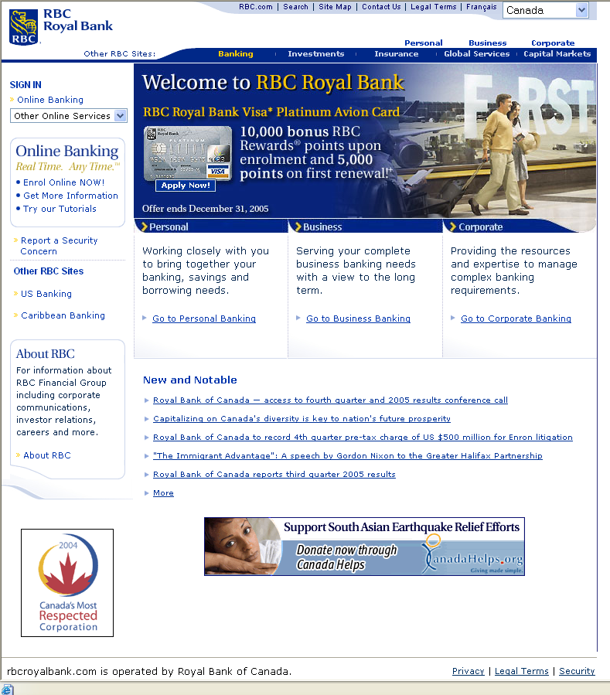

The Royal Bank of Canada provides both traditional banking and online banking services. It has many branches in Canada and has customers all over the world.
  - Identify two online banking services, which the bank might provide for its customers.
[2 marks]
  - Outline two advantages for the customer of an online bank over a traditional bank.
[2 marks]
  - Banks store customers’ personal data. The bank must have a policy covering the storage and use of this data. Describe two rules that must be included in this policy.
[4 marks]

  - Discuss three social and/or ethical concerns that customers should have about storage of their personal data. Evaluate your arguments.

[12 marks]

Total: [20 marks]

