ITGS Exam Prep 8 Name: _________________________________
2.2.6 Tutorials, training and wizards (assistants)

A software company called Jes-Basketball (http://www.jes-basketball.com) produces software called Basketball Playbook which allows users to create new "plays" which are then animated and can be played on a computer using the free playbook viewer. The manufacturer claims that the program allows coaches to develop better plays and makes it easier and faster for players to learn the plays.

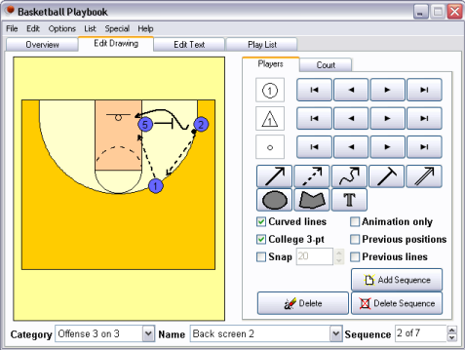

The athletic director at Shanghai International School has decided to use Basketball Playbook with all of the basketball teams for the next season. He has purchased a multi-user license from Jes-Basketball and has had the program and the "Read Me" file installed on the computers of all the basketball coaches and assistants.
- Basketball Playbook comes with a "Read Me" file - define "Read Me" files. [2 marks]
_____________________________________________________________________________________________________________________________________________________________________________________________________________________________________________
- Describe two wizards that might be found in software such as this. [4 marks]
_____________________________________________________________________________________________________________________________________________________________________________________________________________________________________________
______________________________________________________________________________________________________________________________________________________________
- Explain who is responsible for the coaches learning to use this software correctly. [4 marks]
_____________________________________________________________________________________________________________________________________________________________________________________________________________________________________________
_____________________________________________________________________________________________________________________________________________________________________________________________________________________________________________
_____________________________________________________________________________________________________________________________________________________________________________________________________________________________________________
- Evaluate the decision to use computer software to assist sport coaches at schools with particular reference to the training needed to use the programs. [10 marks]
______________________________________________________________________________________________________________________________________________________________________________________________________
______________________________________________________________________________________________________________________________________________________________________________________________________
______________________________________________________________________________________________________________________________________________________________________________________________________
______________________________________________________________________________________________________________________________________________________________________________________________________
____________________________________________________________________________________________________________________________________
__________________________________________________________________
__________________________________________________________________

